Therapeutic Use Exemption (TUE) Form

Application for a Therapeutic Use Exemption of a Prohibited Substance and/or Prohibited Method

Please complete all sections in capital letters or typing. This application will be reviewed by a panel of medical professionals appointed by BDADC, bound by strict confidentiality. Please supply relevant medical details and reports to allow BDADC to formulate an informed decision on this application. If no supporting medical documents are attached, the application will be returned to the applicant.

Please return this form and supporting documentation to BDADC Secretariat, Stadium Negara Hassanal Bolkiah, via email to tue.bdadc@gmail.com

 | 1. | Athlete Information
 | Title Dr | Mr Mrs | Surname |  |  | Given Name(s)
 | Miss Ms
 | Gender |  | Date of Birth (dd/mm/yyyy)
 | Male | Female
 | Address
 | Town |  |  |  |  | Region/State | Postcode
 | Country
 | Email
 | Phone (home) |  |  |  | Mobile
 | National Sporting Organisation |  |  |  | Discipline/position
 | Athlete with a disability Yes No |  |  | If yes please indicate disability





^{Page 1 of 6} TUE Application Form – BDADC


- Notifying medical practitioner (please write clearly using block letters or practice stamp)

Surname | Given Name(s)

Specialty and qualifications

Address

Town | Region/State | Postcode

Country

Email

Phone (work) | Mobile

 | 3. | Previous TUE
 | Have you previously had, or do you currently have, any TUE(s)? Yes |  | No





If yes, please attach any current or relevant TUE(s) to this application or please fill out the following information in relation to those applications:

Date | Anti-Doping Organisation/TUE Committee | Substance


Have you previously had any TUE applications rejected? Yes No
If yes, please fill out the following information in relation to those applications:

Date | Anti-Doping Organisation/TUE Committee | Substance

^{Page 2 of 6} TUE Application Form – BDADC


4. Retroactive TUE

Is this application for a retroactive TUE? No – go to Q5 Yes – indicate below

A retroactive TUE is for treatment involving a prohibited substance or method that has already commenced and can only be sought for the following circumstances:


Yes - Emergency treatment or treatment of an acute medical condition was necessary

Yes - “Exceptional circumstances” means that there was insufficient time for BDADC to consider the application

If the retroactive request is for a substance/method detected as a result of doping control, please state:

date of sample collection: ________________ substance/method detected: ____________________


5. Medication/Treatment details (please write clearly using block letters)

Medication/Treatment | Prohibited | Dose & | Route of | Duration
 | Substances/Method | Frequency | Administration

Page 3 of 6 | TUE Application Form – BDADC


6. Diagnosis with medical information (please write clearly using block letters)

Evidence confirming the applicant’s diagnosis (in the form of a typed letter) MUST BE ATTACHED to this application.

The medical evidence should include clinical history and the results of all examinations, investigations, imaging studies and specialist medical reports. Copies of the original reports or letters should be included when possible. Evidence should be as objective as possible in the clinical circumstances and in the case of non-demonstrable conditions, independent supporting medical opinion will assist this application. Any additional investigations, examinations or imaging studies requested by BDADC will be undertaken at the expense of the applicant or his/her National Sporting Organisation.

If a permitted substance or method is available to treat the medical condition, provide clinical justification for the requested use of the prohibited substance or method:

Full details of all medications or treatments that have been trialled:

Additional comments:

Page 4 of 6 | TUE Application Form – BDADC


7. Athlete application, authority and declaration

I, ________________________________________________ declare that the information I provide in connection with this application is accurate and complete. I request that BDADC provide me with an approval to use a substance or method that is prohibited by the rules of my sport. I consent to personal information relating to me being disclosed to, and used by relevant persons, bodies and agencies as appropriate for the consideration of this application (and any appeal) and the implementation, co-ordination, administration, monitoring and enforcement of the therapeutic use exemptions under the relevant national and international anti-doping programs of my sport. I understand that relevant persons include, but are not limited to, BDADC staff, medical practitioners consulted by BDADC and BDADC’s agents. I understand that if I wish to revoke the consent, I must notify my medical practitioner and BDADC in writing to highlight that effect.

Signature of athlete: | Date:
Signature of Parent or Guardian | Date:
(Athletes under 18years age)


8. Medical practitioner’s declaration

I, ________________________________________________ declare the abovementioned medication/s for the above named athlete is the medically appropriate treatment for the above named medical condition. I further certify that the use of alternative medications or methods not on the WADA Prohibited List would be unsatisfactory for the treatment of the above medical condition.

Signature of medical practitioner: Date:

Page 5 of 6 | TUE Application Form – BDADC

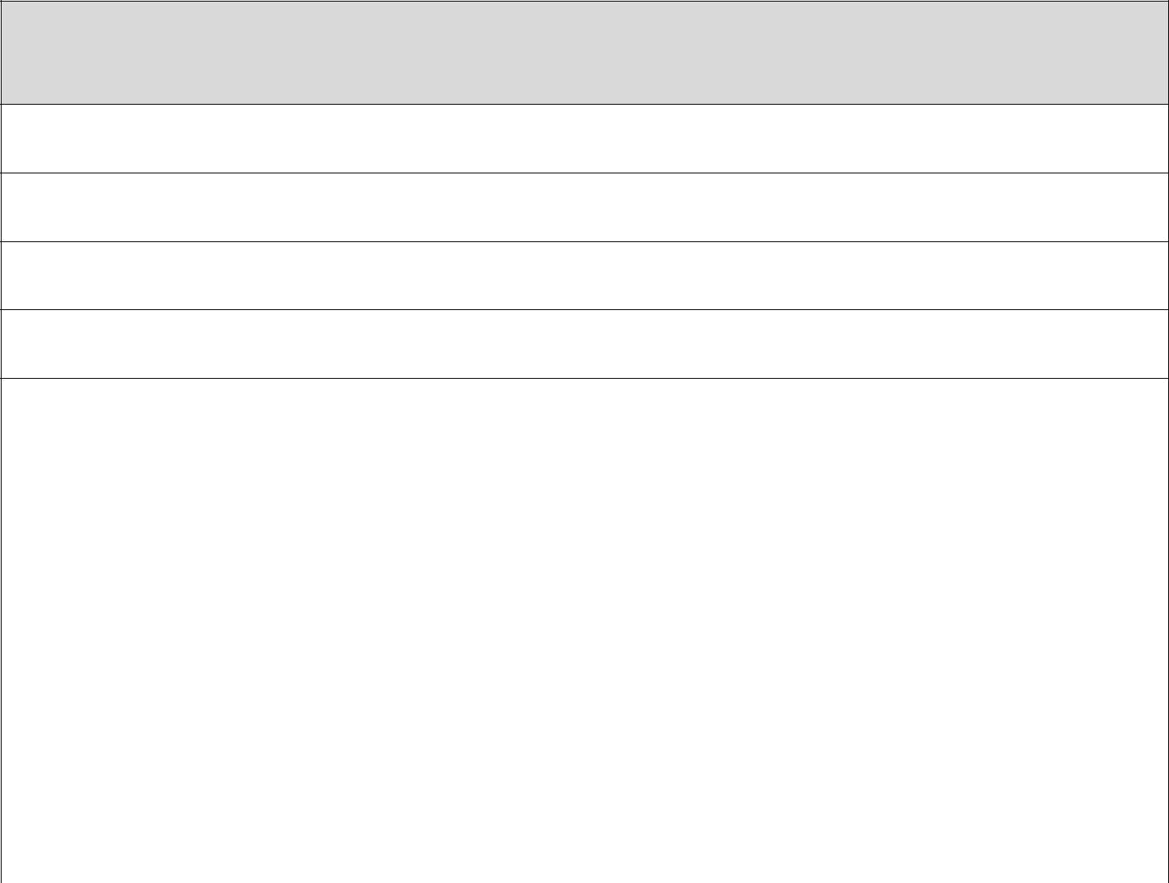
9. Application checklist (please complete before sending application)

1. Athlete details complete


2. Medical practitioner details complete

3. TUE application details complete

4. Retroactive TUE

- Medication details including all medications and treatments tried (generic names and doses)

Separate diagnosis and medical evidence attached:

(a) Comprehensive medical history;

(b) Results of examinations, laboratory investigations, imaging studies and/or specialist medical reports;

(c) Copies of original reports or letters (where appropriate).

6. Diagnosis with medical information

7. Athlete declaration signed

8. Medical practitioner declaration signed


Please note:

Where the Athlete already has a TUE granted by his or her National Anti-Doping Organization for the substance or method in question, that TUE is automatically valid for international-level Competition provided that such TUE decision has been reported in accordance with Article 5.4 of the International Standard for Therapeutic Use Exemption and therefore are available for review by WADA.

Page 6 of 6 | TUE Application Form – BDADC

